Udacity Project: Explore Weather Trend

**Steps**

1. Extract weather data of Vienna from database with SQL query:

**SQL query:**

SELECT c.year, c.city, c.country, c.avg_temp local_temp,

g.avg_temp global_temp

FROM city_data c

JOIN global_data g

ON c.year = g.year

WHERE country = 'Austria';

1. Download data as CSV file and conduct moving-average analysis with excel.
2. 7-Year MA is calculated by using function “average” in excel.
   * Add two columns: one for 7-year MA (local) and the other for 7-year MA (global).
   * For 7-year MA (local), select the first 7 years of local_temp and average the values by using function “average”. Then drag the formula until the bottom of the dataset.

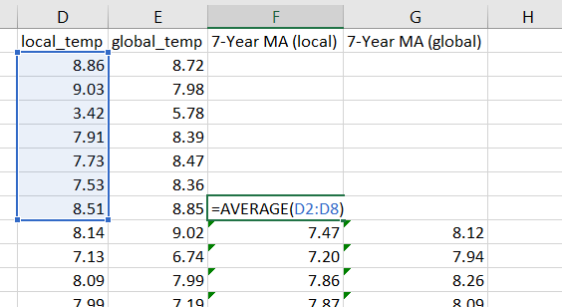

* + For 7-year MA (global), select the first 7 years of global_temp and average the values by using function “average”. Then drag the formula until the bottom of the dataset.

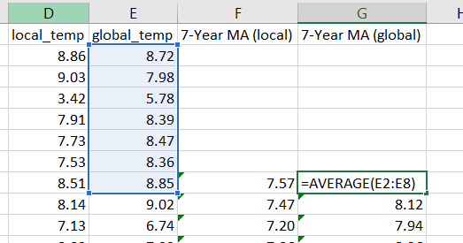

1. Key considerations for data visualization include:
   * Type of chart: Line chart
   * Legend: avg_temp_local and avg_tmp_global
   * Titles of axis: x-year and y-average temperature
   * Chart titles: Vienna Weather Trend

**Chart**

**Observation**

1. Both average global temperature and average local temperature is increasing year by year. The average temperature in both cases were around 8 °C. The average temperatures were around 10 °C locally and globally.
2. In general, the average temperature in Vienna is lower than the average global temperature.
3. The average temperatures in both cases were relatively low at the beginning of 19th century.
4. The trend of average global temperature is consistent with average local temperature, both increasing in the long term.